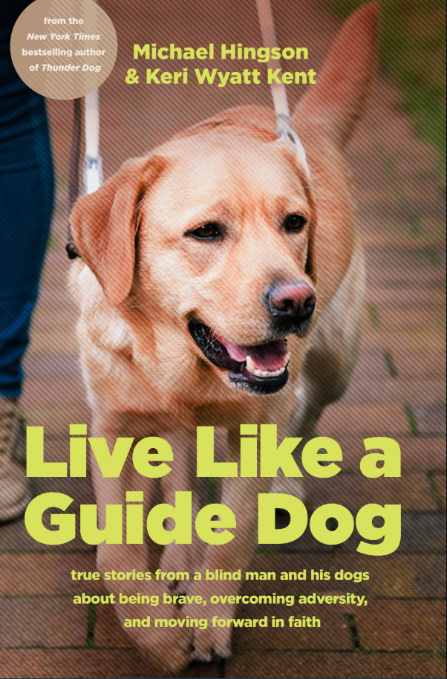
Discussion Questions for Groups

Squire–Awareness Builds Confidence
- How did Michael use echolocation as a means of seeing his surroundings? How did this help build his confidence of playing with the other neighborhood kids like Cindy?
- How does Michael explain regulating and controlling his fear in order to keep his guide dog calm?
- Michael says, “My dog draws courage from me, and I draw courage from my dog.” Before this book, were you aware of this symbiotic relationship between a person and a guide dog? What are you learning as a result of Michael’s story?
- How can awareness of our situations and surroundings help us overcome our fears?
- “Awareness allows you to leverage your fear and deal with what is going on.” How will you use this advice the next time you feel afraid? What will you do to combat the fear?
Holland–Preparation Prevents Panic
- How did Michael face his fears and trust God during his early professional days of moving around the nation and navigating new cities? How did Holland aid him during this process?
- Think of a time you faced a decision and were afraid of the unknown. What did you do to help overcome this and find a solution?
- What are some of the ways in which Holland taught Michael to be brave and “move forward and walk by faith”?
Klondike–Perseverance Strengthens Your Spirit
- What are some of the ways in which Klondike taught Michael to “persevere even when times were hard”?
- During tough times in his life, Michael recounts leaning on God and trusting in him to get through the difficult days. What are some ways in which you’ve felt God’s presence in your life, guiding you through your own tough times?
- In this chapter, Michael shares about losing his mother soon after his dog Holland had passed. How does grief and loss impact our ability to be brave? What enabled him to move forward in the wake of these losses?
Linnie–Empathy Builds Courageous Connections
- Has the fear of rejection ever stopped you from connecting with someone or trying something new? What are some lessons we can learn from Linnie on how to overcome our fear of rejection?
- Michael highlights that Linnie often reminded him that “connection can ease our fears.” What are some ways in which Linnie helps Michael realize this?
- “God’s guidance comes when we pay attention.” What are some of the ways in which you can slow down and look for his guidance in your life?
Roselle–Trust and Teamwork Build Bravery
- Compare Roselle’s reaction to the thunderstorm at home in the early hours of 9/11 and how she reacted in Tower One when the plane hit. What do you notice and why?
- How did Michael and Roselle’s shared trust in one another and effective teamwork lead them and others to safety on 9/11?
- One life lesson Mike gleaned from his experience on 9/11 was “Don’t worry about what you can’t control.” How often do you worry about things beyond your control? Think about a situation you’re facing: What can you control? What can you not control?
Meryl–Rest Rejuvenates Our Courage
- Can you relate to Meryl’s type A personality? In your experience, how do different personality types respond to fear and/or demonstrate courage? What lessons can we take away from this?
- In this chapter, Mike tells the story of missing a flight and having to spend the night in an airport. Tell about a time when you had to face unexpected changes in your plans, and how that made you feel. What enabled Mike and Meryl to be brave despite their circumstances?
Africa–Faith Drives Out Fear
- Has there been a time in your life when God invited you to “face [your] fears and walk boldly forward” and trust him to get you through?
- In this chapter, Mike tells about experiencing fear about his finances, a very common fear. What do you think drives people’s fear about money? How have you experienced this?
- Also in this chapter, Mike describes traveling and flying with Africa. What surprised you about their experiences on airplanes?
Fantasia–Your Instincts Will Protect You
- How did Fantasia’s change in behavior help allude to Karen’s health problem?
- Michael was certain Karen would rally with Fantasia by her side. Have you experienced a similar situation with one or more of your pets? Explain.
- In this chapter, Michael notes that “fear is sometimes a gift to help us find the path to courage.” What do you think that means? Share about a time you experienced that path in your own life.
Alamo–Forward Gets You Unstuck
- What is the fundamental difference between Alamo’s closeness and behavior to Michael compared to Meryl’s? Which of these more closely resembles your behavior and relationship to God?
- What do you think it means to be “stuck”? How is fear connected to that?
- In this chapter, Michael asks, “Do we invoke the power of God to do the things that we need to do?” How would you answer this question? Explain.
- Loss is a part of life, but it sometimes can make us feel afraid. How did Michael cope with loss? What can you learn from his response to difficult circumstances?
Follow-Up Questions
- What is something new you learned from this book? Are there any lessons you’re going to take away after hearing about Michael’s experience with his guide dogs?
- What are some steps you can take to control your fear after reading this book?
- What do you think it means to “live like a guide dog”? What is one thing you will do differently as a result of reading this book?

